**Light Up the Green World . LED Downlights Expert 7 Years**

**Warraty 3/5 Years**

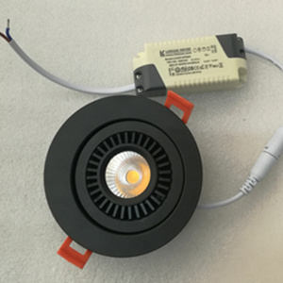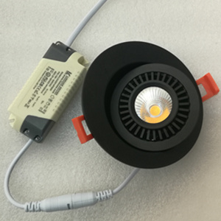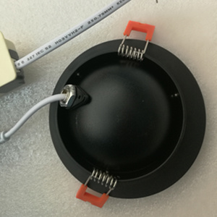

1. **Model No.** RADL005

**Product Name:** 360°Rotatable LED Downlight

|  |  |  |  |  |  |  |  |  |  |
| --- | --- | --- | --- | --- | --- | --- | --- | --- | --- |
| **Model No.** | **Power** | **Lumen(lm)** | **Driver Brand** | **LED Style** | **CCT(K)** | **Beam Angle** | **CRI** | **Size(mm)** | **Cutout(mm)** |
| RADL005-A | 3W | 250lm | Philips Driver | CREE COB | 3000K  4000K  5000K | 60° | RA>80  RA>90 | D70*H30 | D55 |
| RADL005-B | 5W | 400lm | D88*H33 | D75 |
| RADL005-C | 7W | 600lm | D110*H35 | D95 |

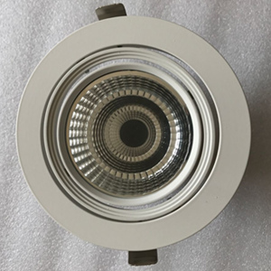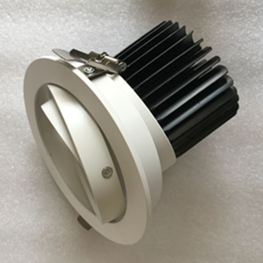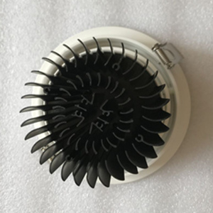

1. **Model No.** SD005-6F

**Product Name:** Double Rings Adjustable Downlight

|  |  |  |  |  |  |  |  |  |  |
| --- | --- | --- | --- | --- | --- | --- | --- | --- | --- |
| **Model No.** | **Power** | **Lumen(lm)** | **Driver Brand** | **LED Style** | **CCT(K)** | **Beam Angle** | **CRI** | **Size(mm)** | **Cutout(mm)** |
| SD005-6F | 30W | 2700lm | Philips Driver | CREE COB | 3000K  4000K  5000K | 24° | RA>80  RA>90 | D165*H95 | D145 |
| SD005-8F | 40W | 3500lm | D198*H130 | D165 |

**Light Up the Green World . LED Downlights Expert 7 Years**

**Warraty 3/5 Years**

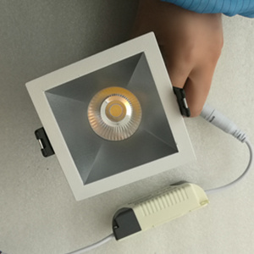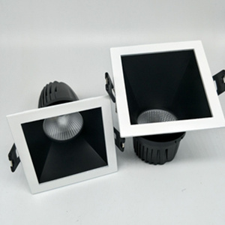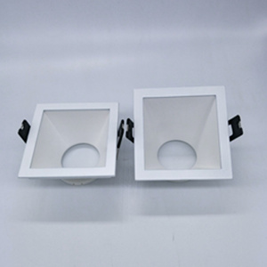

1. **Model No.** TSD0810

**Product Name:** Oblique Square LED Downlight

|  |  |  |  |  |  |  |  |  |  |
| --- | --- | --- | --- | --- | --- | --- | --- | --- | --- |
| **Model No.** | **Power** | **Lumen(lm)** | **Driver Brand** | **LED Style** | **CCT(K)** | **Beam Angle** | **CRI** | **Size(mm)** | **Cutout(mm)** |
| TSD0810-A | 10W | 850lm | Philips Driver | CREE COB | 3000K  4000K  5000K | 24° | RA>80  RA>90 | SQ85*H110 | L78*W78 |
| TSD0810-B | 5W | 430lm | SQ85*H80 | L78*W78 |

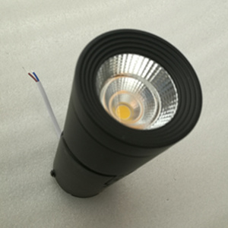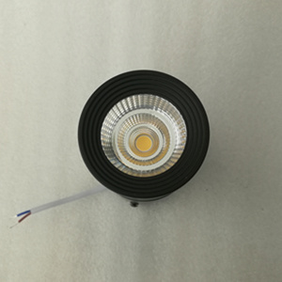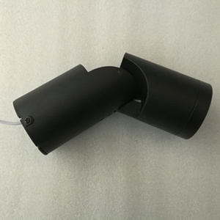

1. **Model No.** ASMDL002-3F

**Product Name:** Adjustable Surface Mounted LED Downlight

|  |  |  |  |  |  |  |  |  |
| --- | --- | --- | --- | --- | --- | --- | --- | --- |
| **Model No.** | **Power** | **Lumen(lm)** | **Driver Brand** | **LED Style** | **CCT(K)** | **Beam Angle** | **CRI** | **Size(mm)** |
| ASMDL002-3F | 10W | 850lm | Philips Driver | CREE COB | 3000K  4000K  5000K | 24° | RA>80  RA>90 | D68*H1198 |